


Monthly Report
April 2026

AccèsBanque Madagascar

Contents
Contents 1
1. Executive Summary 2
1.1. Key Highlights: 2
1.1.1. Incident Volume & Trends: 2
1.1.2. Detection & Response Performance: 2
1.2. Incident Trends & Analysis: 4
1.3. High-Severity Incidents & Escalations: 5
2. April Alerts & Incidents Overview 7
2.1. Overall Volume 7
2.2. Incident Processing and Classification 7
2.3. Mean Time to Detect (MTTD) 8
3. Incidents Highlights 10
3.1. Top 10 incidents by type 10
3.2. Analysis of Key Incident Trends 11
3.3. VPN Connections 14
3.4. High Severity 15
3.4.1. High Severity Incident Analysis 15
4. Cybersecurity Trends and Threats (April 2026) 18
4.1. Key Threats and Incidents 18
4.2. Regional Spill-over and Infrastructure Risks 20
4.3. Government and Infrastructure Response 21
5. Conclusion 23

Executive Summary
This report from TeKnowledge presents a comprehensive analysis of security incidents, alerts, and operational activities within the AccèsBanque Madagascar environment. It outlines key security trends, assesses detection and response performance, and showcases TeKnowledge’s continued capability in effectively identifying, managing, and mitigating security threats.

Key Highlights:

Incident Volume & Trends:
A total of 1320 security incidents were processed in Microsoft Sentinel, a slight increase from previous total of 1309 incidents. This total encompasses both manually investigated cases and automated detections.
The most prevalent security events now include Multiple Failed Logons Specific ID4625, Logon activity from a potentially harmful application, Failed logon attempts by valid accounts within 10 mins, and Incidents Summary Alert, highlighting the growing importance of continuous monitoring of privileged users’ activities to ensure system integrity and minimize potential abuse.

Detection & Response Performance:
Mean Time to Detect (MTTD): 2 minutes and 47 seconds. This highlights the effectiveness of real-time monitoring enhancements, fine-tuned detection workflows, and automation-driven alerting mechanisms.
Additionally, the breakdown of MTTD by severity is as follows:
High Severity: 5 minutes and 25 seconds
Medium Severity: 2 minutes and 51 seconds
Low Severity: 2 minutes and 13 seconds
Informational Alerts: 2 minutes and 39 seconds
Average time to First Response: The Average Time to First Response for April was 37 minutes, major increase from 3 minutes in March. This rise was primarily due to ticketing system downtime and instability following a platform upgrade, which delayed case creation and assignment. As a result, initial analyst response times were impacted despite ongoing monitoring and triaging efforts. See the screenshot below for the breakdown.
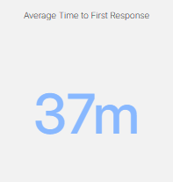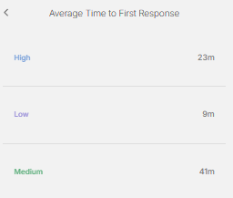
Average Mean Time to Resolution (MTTR): The average Mean Time to Resolution (MTTR) for this reporting period was 33 minutes across all severity levels. The screenshot below provides a detailed breakdown by severity, further highlighting the efficiency and responsiveness of our incident handling process.
` 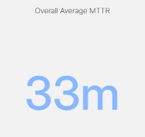 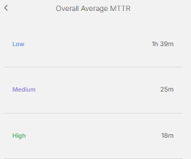

Availability Rate: The service availability rate for the month was 99.60%, calculated based on total uptime versus total possible uptime, factoring in the ticketing system downtime. While this downtime impacted case logging and record management, core SOC monitoring and detection services remained fully operational with an availability rate of 100%. We ensured a high level of responsiveness throughout the period through continuous monitoring via the SIEM platform, Microsoft Sentinel.

Incident Trends & Analysis:
A total of 1320 incidents were recorded and addressed, with 970 of them falling within the top 10 recurring incident types.
The most frequent alerts were related to:
- Multiple Failed Logons Specific ID4625 - 511
- Logon activity from a potentially harmful application - 81
- Failed logon attempts by valid accounts within 10 mins - 75
- Incidents Summary Alert - 60
- Change Group Member - 58
- FortiGate VPN Connection Established by aimnomen0925 - 53
- FortiGate VPN Connection Established by honrajer2389 - 38
- VPN EZVPN_CONNECTION_UP - 33
- FortiGate VPN Connection Established by r. rakotonanahary - 33
- Add a group - 28

All incidents were carefully reviewed and escalated where required, contributing to the continued operational stability and protection of critical assets.
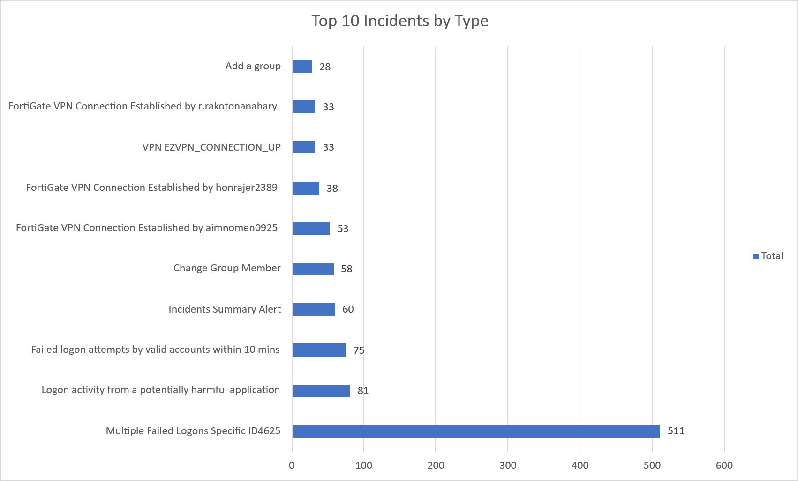

High-Severity Incidents & Escalations:
During this reporting period, 11 high-severity incidents were recorded, requiring immediate attention and remediation. The key incidents included:
- Privileged Accounts - Sign in Failure Spikes - 7
- [AD Enumeration]: 1744 Access Events to LDAP-related Objects by honrajer2389_adm - 1
- Log4j vulnerability exploit aka Log4Shell IP IOC - 1
- Authentication Methods Changed for Privileged Account - 1
- Authentication Method Changed for Privileged Account - 1

April Alerts & Incidents Overview

Overall Volume
In April, a total of 1320 incidents were handled on MS Sentinel. This volume includes both incidents that were manually processed by our security team and those that were automatically addressed through pre-configured automation protocols.
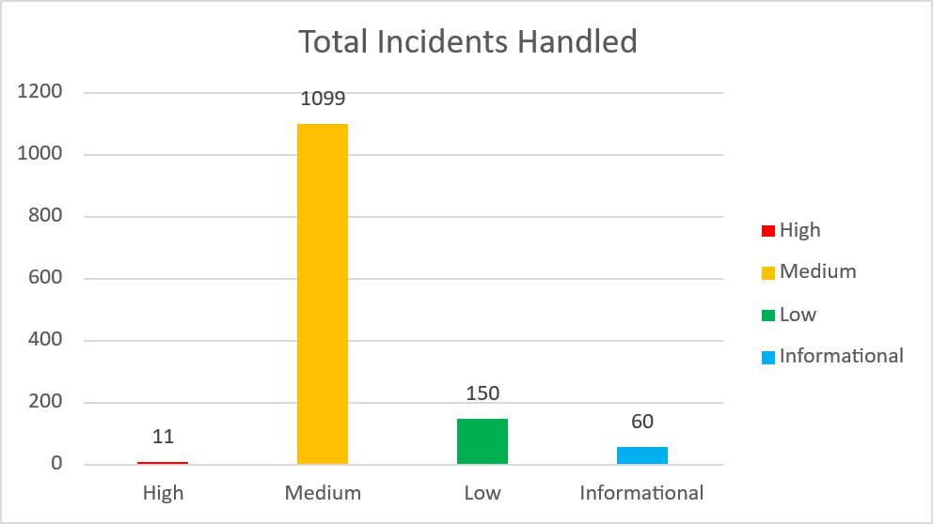

Incident Processing and Classification
During the reporting period, TeKnowledge successfully monitored, detected, and responded to a total of 1320 security alerts within the AccèsBanque Madagascar environment. The SOC team processed all incidents, ensuring a comprehensive approach to threat detection and response. The most prevalent security events now include Multiple Failed Logons Specific ID4625, Logon activity from a potentially harmful application, Failed logon attempts by valid accounts within 10 mins, and Incidents Summary Alert, highlighting the ongoing need for robust identity security and access control measures.
The final classification breakdown comprised 1237 benign positives, 15 true positives, 1 false positive and 38 undetermined.
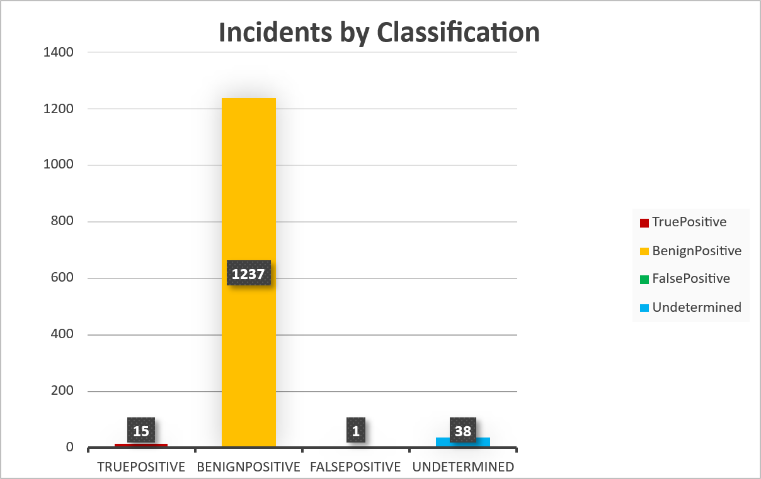

This outcome reflects a structured alert review process that emphasizes accurate categorization and effective incident validation, ensuring that remediation efforts remain focused on genuine security threats while minimizing operational noise.

Mean Time to Detect (MTTD)
The average Mean Time to Detect (MTTD) for this reporting period was recorded at 2 minutes and 47 seconds.
This highlights TeKnowledge’s continued efforts to optimize detection workflows, enhance real-time monitoring, and fine-tune security operations. With these refinements, the SOC team has successfully reduced detection times, ensuring faster identification and containment of potential security threats. Moving forward, further enhancements in automation and alerting mechanisms will aim to maintain and improve this trend.

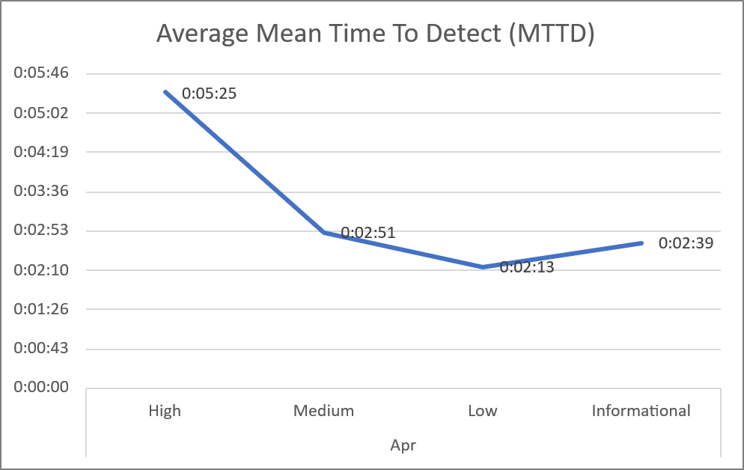

The breakdown by severity shows consistent detection across all levels, with particularly fast response times for low and medium severity alerts. Although high-severity detection is slightly elevated, it remains within an acceptable range given the approved SLA.
Overall, the SOC team has demonstrated strong capability in rapidly identifying and containing potential threats.

Incidents Highlights

Top 10 incidents by type
During the reporting period, TeKnowledge monitored and categorized security incidents, identifying the most prevalent issues within your environment. Below is a breakdown of the top incident types detected:

Incident Details | Count of Title
Multiple Failed Logons Specific ID4625 | 511
Logon activity from a potentially harmful application | 81
Failed logon attempts by valid accounts within 10 mins | 75
Incidents Summary Alert | 60
Change Group Member | 58
FortiGate VPN Connection Established by aimnomen0925 | 53
FortiGate VPN Connection Established by honrajer2389 | 38
VPN EZVPN_CONNECTION_UP | 33
FortiGate VPN Connection Established by r.rakotonanahary | 33
Add a group | 28
Grand Total | 970

Analysis of Key Incident Trends
During this reporting period, TeKnowledge identified and categorized multiple security incidents within the AccèsBanque Madagascar environment. The breakdown below highlights key trends, notable threat patterns, and actionable recommendations to improve detection and response capabilities
- Multiple Failed Logons Specific ID 4625 – (511 Incidents)
Description: Multiple failed logon attempts were detected, as recorded by Event ID 4625. This may indicate brute-force attempts, incorrect credential use, or misconfigured authentication settings on one or more systems.
Recommendation: Review the source and frequency of failed attempts to confirm whether they are legitimate user errors or unauthorized access attempts. Implement account lockout policies, enforce Multi-Factor Authentication (MFA), and continue monitoring for repeated or widespread failures.
- Logon Activity from potentially Harmful Application – (81 Incidents)
Description: Login attempts were initiated through applications flagged as potentially harmful or untrusted. This behavior could indicate malware or unauthorized tools.
Recommendation: Immediately isolate affected endpoints, run malware scans, and enhance application whitelisting/enforcement policies. However, most of these were identified as internal vulnerability assessments stemming from the designated Nessus server.
- Failed logon attempts by valid accounts within 10 – (75 Incidents)
Description: Multiple failed logon attempts were observed from valid user accounts within a 10-minute window. This behavior may indicate brute-force activity, credential misuse, or user input errors across multiple login sessions.
Recommendation: Review the affected accounts and verify if the attempts originated from expected users or systems. If unauthorized, initiate a password reset and enforce account lockout policies and Multi-Factor Authentication (MFA) to mitigate potential compromise attempts.
- Incident Summary Alert – (60 Incidents)

Description: This provides a consolidated view of security events detected within a 12h period. These alerts are generated based on correlation rules and analytics that identify potentially suspicious or malicious activities across the environment. The purpose of these alerts is to highlight notable security events that require review, validation, or response.
- Change Group Member – (58 Incidents)
Description: Group membership changes were detected. Unauthorized privilege escalation could occur via adding users to sensitive groups.
Recommendation: Confirm changes were authorized, enforce approval workflows, and regularly audit critical groups (e.g. administrators).
- FortiGate VPN Connection Established by aimnomen0925 – (53 Incidents)
Description: Multiple VPN connections were established using the account aimnomen0925 through FortiGate. High frequency or unexpected use in April indicates compromised credentials or malicious automation.
Recommendation: Verify user activity legitimacy, enforce MFA for VPN access, and consider temporary account suspension pending investigation.
- FortiGate VPN Connection Established by honrajer2389 – (38 Incidents)
Description: Multiple VPN connections were established using the account honrajer2389 through FortiGate. High frequency or unexpected use in April indicates compromised credentials or malicious automation.
Recommendation: Verify user activity legitimacy, enforce MFA for VPN access, and consider temporary account suspension pending investigation.
- VPN EZVPN_CONNECTION_UP – (33 Incidents)
Description: Multiple VPN connections were established through EZVPN, indicating repeated remote access activity. These connections may represent normal user behavior or potentially unauthorized access attempts. Recommendation: Verify user activity legitimacy, enforce MFA for VPN access, and consider temporary account suspension pending investigation.
- FortiGate VPN Connection Established by r. rakotonanahary – (33 Incidents)
Description: Multiple VPN connections were established using the account r.rakotonanahary through FortiGate. High frequency or unexpected use in April indicates compromised credentials or malicious automation.
Recommendation: Review the source IPs, user accounts, and timestamps of the VPN connections. Confirm whether the activity aligns with expected usage. Enforce MFA for VPN access and consider implementing stricter session monitoring to detect anomalies
- Add a group – (28 Incidents)
Description: Group creation activities were detected within the environment. While this may be part of routine administrative tasks, unauthorized or unapproved group creation could be used to establish persistence, facilitate privilege escalation, or bypass existing access controls. Such actions may indicate misuse of administrative privileges or malicious intent if not properly validated.
Recommendation: Verify that group creation activities were authorized and aligned with organizational policies. Restrict group creation privileges to approved administrators, implement approval workflows for new group creation, and conduct regular audits of newly created groups to ensure they are appropriately configured and not misused.

VPN Connections
During the reporting period, VPN usage remained a critical component in ensuring secure remote access to the AccèsBanque Madagascar internal network and systems. A total of 300 VPN connection alerts were recorded. This figure includes both initial events and subsequent user reconnections throughout the month, reflecting overall VPN activity rather than unique user counts.
Incident Data | Count of Title
FortiGate VPN Connection Established by aimnomen0925 | 53
FortiGate VPN Connection Established by honrajer2389 | 38
VPN EZVPN_CONNECTION_UP | 33
FortiGate VPN Connection Established by r.rakotonanahary | 33
FortiGate VPN Connection Established by t.randriantsoa | 26
FortiGate VPN Connection Established by lioratsi3733 | 21
FortiGate VPN Connection Established by t.randriamalala | 16
FortiGate VPN Connection Established by jedmanah1525 | 16
FortiGate VPN Connection Established by andrasoa2878 | 16
FortiGate VPN Connection Established by lovrazon3583 | 9
FortiGate VPN Connection Established by andandri3823 | 8
FortiGate VPN Connection Established by t.lhorca | 7
FortiGate VPN Connection Established by s.andriamialy | 6
FortiGate VPN Connection Established by i.zaitsev | 6
FortiGate VPN Connection Established by s.rasoamanana | 4
FortiGate VPN Connection Established by rovrajoe3339 | 4
FortiGate VPN Connection Established by paulin.rakotonirina | 2
FortiGate VPN Connection Established by fenratov1960 | 1
FortiGate VPN Connection Established by norandri0061 | 1
Grand Total | 300

High Severity
During the reporting period, 11 high-severity incidents were recorded. These incidents were thoroughly investigated and determined to be authorized and legitimate.

High Severity Incident Analysis
- Privileged Account: Sign-in Failure Spike - (7 Incidents)
Description: Multiple failed sign-in attempts were detected for privileged accounts, which could indicate brute-force attempts, credential stuffing, or misconfigured authentication settings.
Recommendation: Implement account lockout policies for failed sign-ins, enforce Multi-Factor Authentication (MFA) for privileged users, and monitor login trends to detect potential account compromise.
- [AD Enumeration]: 1744 Access Events to LDAP-related Objects by honrajer2389_adm – (1 Incident)
Description: A high volume of access events to LDAP-related objects was detected for the account honrajer2389_adm. This behavior may indicate Active Directory enumeration which can be used to gather information for lateral movement or privilege escalation. While potentially legitimate for administrative tasks, the pattern is considered suspicious upon validation.
Recommendation: Validate whether the activity was authorized. If not, investigate for potential account compromise, reset credentials, and review recent actions. Limit unnecessary directory access and enable monitoring for similar enumeration behavior.
- Log4j vulnerability exploit aka Log4Shell IP IOC
Description: An indicator of compromise linked to Log4Shell exploitation attempts was detected from a malicious IP source. This vulnerability allows remote code execution and is commonly targeted by threat actors scanning for exposed systems.
Recommendation: Ensure all systems are patched against Log4j vulnerabilities. Block the identified IP, review logs for signs of exploitation, and implement WAF/IDS rules to detect and prevent similar attempts.
- Authentication Methods Changed for Privileged Account
Description: A change in authentication methods was detected for a privileged account such as modification of MFA settings or security verification details. Unauthorized changes may enable attackers to bypass security controls and maintain access.
Recommendation: Confirm whether the change was authorized. If suspicious, investigate immediately, revert changes, reset credentials, and enforce MFA. Enable alerts for future authentication method modifications on privileged accounts.
- Authentication Method Changed for Privileged Account
Description: An additional instance of authentication method modification was observed on a privileged account, which may indicate an attempt to manipulate access controls or establish persistence.
Recommendation: Review the change for legitimacy, restrict modification privileges, enforce strong MFA policies, and continuously monitor suspicious activity on privileged accounts.

Cybersecurity Trends and Threats (April 2026)
In April 2026, Madagascar’s cybersecurity landscape was shaped by cybercrime enforcement, online abuse and digital defamation risks, child online exploitation concerns, and continued structural exposure in public-sector systems, online payments, and internet-facing services. I did not find a widely verified April 2026 Madagascar-specific ransomware breach comparable to the March Orange Madagascar incident. The April threat picture was instead dominated by cybercriminal, weak legal/technical maturity, public-facing website exposure, and the need for stronger investigative capacity.

Key Threats and Incidents
- Cybercriminal treated as a serious and growing threat
On April 29, 2026, Madagascar Matin described cybercriminal as a serious issue, noting that ICT systems are now targets of malicious acts and that cybercrime covers offenses committed through connected computer systems. The report emphasized that Madagascar’s existing legal framework has struggled to respond to the specificity and seriousness of these cyber offenses.
- Digital defamation and harmful online speech as a major enforcement focus
The same April 29 report highlighted Madagascar’s first specialized cybercrime division within the national police and referenced Article 20 of the cybercrime law, which covers insults and defamation through electronic or computer-supported channels. This indicates that in April, visible enforcement concern focused heavily on online defamation, harmful digital content, and abuse of electronic communication platforms.
- Cybercrime law creates pressure around journalists and online expression
On April 24, 2026, Madagascar Matin reported that journalists remained exposed to Article 20 of the cybercrime law, even as discussions continued around the communication code. From a threat perspective, this reflects a sensitive digital-risk area: online publication, digital speech, and media activity can become legal and cybercrime enforcement issues, creating both compliance risk and chilling effects for online actors.
- Child online exploitation and cyber-abuse risks remained a priority
On April 22, 2026, Madagascar Matin reported that UNICEF trained 170 judicial police officers from the police and gendarmerie on cybercrime, digital investigation techniques, and the legal framework, with specific emphasis on identifying and responding to online sexual abuse and exploitation of children. This signals that children, adolescents, and young users remain high-risk targets for online abuse.
- Public-sector websites and online payment exposure remained a structural threat
On April 29, 2026, Madagascar Matin reported that computer hacking is a real threat affecting communications, automated systems, online payment systems, and public websites. The article also cited prior compromises of state-linked websites, including institutions such as Instat, the Ministry of Foreign Affairs, and the Ministry of Public Security, reinforcing the risk around public-facing digital infrastructure.
- No widely verified April ransomware or major enterprise breach found
Within April 1–30, 2026, The strongest April signals were instead cybercrime enforcement, cyber-abuse risk, public-facing infrastructure exposure, and capacity-building around investigations.

Regional Spill-over and Infrastructure Risks
- Low cyber maturity increases attack success probability
Madagascar’s April reporting continued to frame cybercrime as a growing threat across communications, automated systems, online payments, and websites. This suggests exposure not only to local cybercriminals but also to opportunistic regional actors who target weakly defended public and private systems.

- Internet and social media adoption expands youth exposure
The UNICEF-linked April report emphasized that internet and electronic media bring serious dangers for adolescents and young people. This creates exposure to grooming, sexual exploitation, harassment, cyberbullying, impersonation, and unsafe content sharing, especially where digital literacy and reporting channels remain limited.
- Online payment and public-service systems remain attractive targets
Madagascar Matin’s April 29 cybersecurity coverage explicitly named online payment systems and internet-facing websites among areas exposed to cyberattacks. This is significant because payment systems, public portals, and institutional websites can be used for fraud, data theft, defacement, service disruption, and phishing redirection.
- Legal ambiguity and enforcement focus create institutional risk
The April discussion around Article 20 of the cybercrime law shows that digital speech, journalism, and electronic publications remain closely tied to cybercrime enforcement. This creates compliance and reputational risk for media organizations, activists, and online users.

Government and Infrastructure Response
- Specialized cybercrime division within police operations
Madagascar Matin reported that the first specialized cybercrime division within the national police had been inaugurated earlier, with cybercrime enforcement becoming a visible operational priority. The April report indicates that this division is expected to address offenses committed through digital and electronic systems.
- ARTEC and government moved to strengthen national cybersecurity
On April 29, 2026, Madagascar Matin reported that the Ministry of Posts, Telecommunications and Digital Development, together with ARTEC, intended to implement measures to raise Madagascar’s cybersecurity level. This response is tied to threats affecting communications, automated systems, online payments, and public-facing websites.
- Police and gendarmerie cyber-investigation capacity strengthened
The UNICEF-supported training of 170 judicial police officers improved capacity in digital investigations, cybercrime law, and response to online child exploitation. This is one of the clearest April response actions because it directly increases the number of officers able to investigate cyber-related offenses.
- Cybercrime law remained central to enforcement and deterrence
April reporting repeatedly referenced Madagascar’s cybercrime law as the legal basis for responding to electronic defamation, malicious digital conduct, and online offenses. While enforcement may raise free-expression concerns, it also shows that the government is using cybercrime legislation as a primary tool for deterrence and prosecution.
Sources:
1) https://www.matin.mg/?p=52468
2) https://www.matin.mg/?p=38296
3) https://www.matin.mg/?p=36140
4) https://www.matin.mg/?p=32887

Conclusion
The April 2026 reporting period reflects a stable and resilient security posture within the AccèsBanque Madagascar environment with consistent incident management and continued optimization of detection capabilities. A total of 1,320 security incidents were processed representing a slight increase, largely driven by recurring identity and access-related events rather than new or emerging threat patterns.
Operational performance remained strong despite temporary tooling challenges. The Mean Time to Detect (MTTD) improved to 2 minutes and 47 seconds, demonstrating enhanced monitoring and detection efficiency. While the Time to First Response increased to 37 minutes due to ticketing system downtime during a platform upgrade, response workflows remained active and the Mean Time to Resolution (MTTR) improved to 33 minutes, highlighting effective incident handling once cases were engaged.
From an incident composition perspective, 970 incidents were concentrated within the top 10 categories with the most dominant being Multiple Failed Logons, Logon activity from potentially harmful applications and Failed logon attempts by valid accounts within 10 minutes. These trends continue to emphasize the prominence of identity-based threats, the need for strengthened authentication and access controls.
Alert classification indicates a well-tuned detection environment, with 1,237 benign positives, 15 true positives, 1 false positive, and 38 undetermined cases. While this reflects effective filtering and validation processes, further refinement of detection rules will help reduce undetermined cases and improve overall analyst efficiency.
A total of 11 high-severity incidents were recorded and successfully contained which includes privileged account sign-in failure spikes and isolated suspicious or exploit-related activities such as AD enumeration and Log4Shell IOC detection. All incidents were investigated and determined to be controlled, demonstrating strong containment and response capabilities.
Externally, Madagascar’s cybersecurity landscape in April continued to highlight structural risks including cybercrime activity, online abuse, and exposure of public-facing systems. Increased focus on cybercrime enforcement and capacity building reflects a growing national response but also underscores the need for continued vigilance against evolving threats such as phishing, exploitation and misuse of digital platforms.
In conclusion, TeKnowledge has maintained strong operational effectiveness and adaptability throughout April 2026. To further enhance security posture and operational efficiency, continued focus should be placed on:
* Strengthening identity and access management (IAM), particularly MFA enforcement and monitoring of authentication changes.
* Improving system resilience and contingency processes to mitigate tooling-related disruptions.
* Enhancing detection tuning to reduce undetermined alerts and improve response efficiency.
* Increasing user awareness and monitoring to address evolving regional cyber risks.
Overall, the security posture remains stable and effective, with clear opportunities for continued optimization in response to both operational and environmental challenges.

